**Task 1:-**

* AWS account created
* Launched amazon linux from ec2 instance

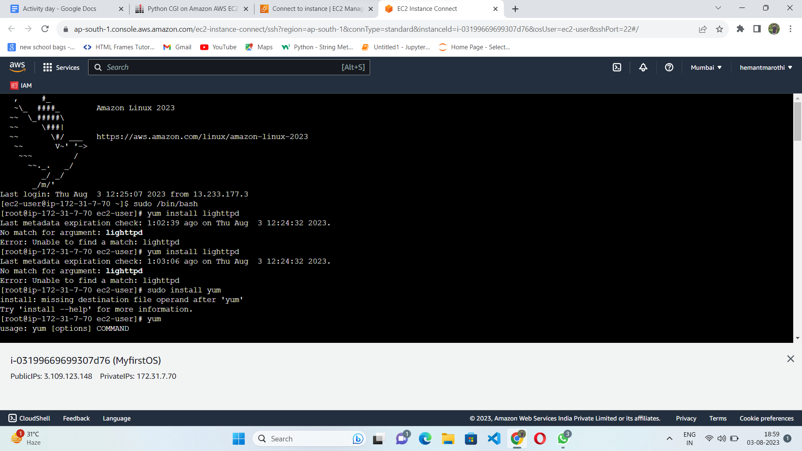

**Task 2:-**

* Anaconda installed
* Opencv installed
* code:-

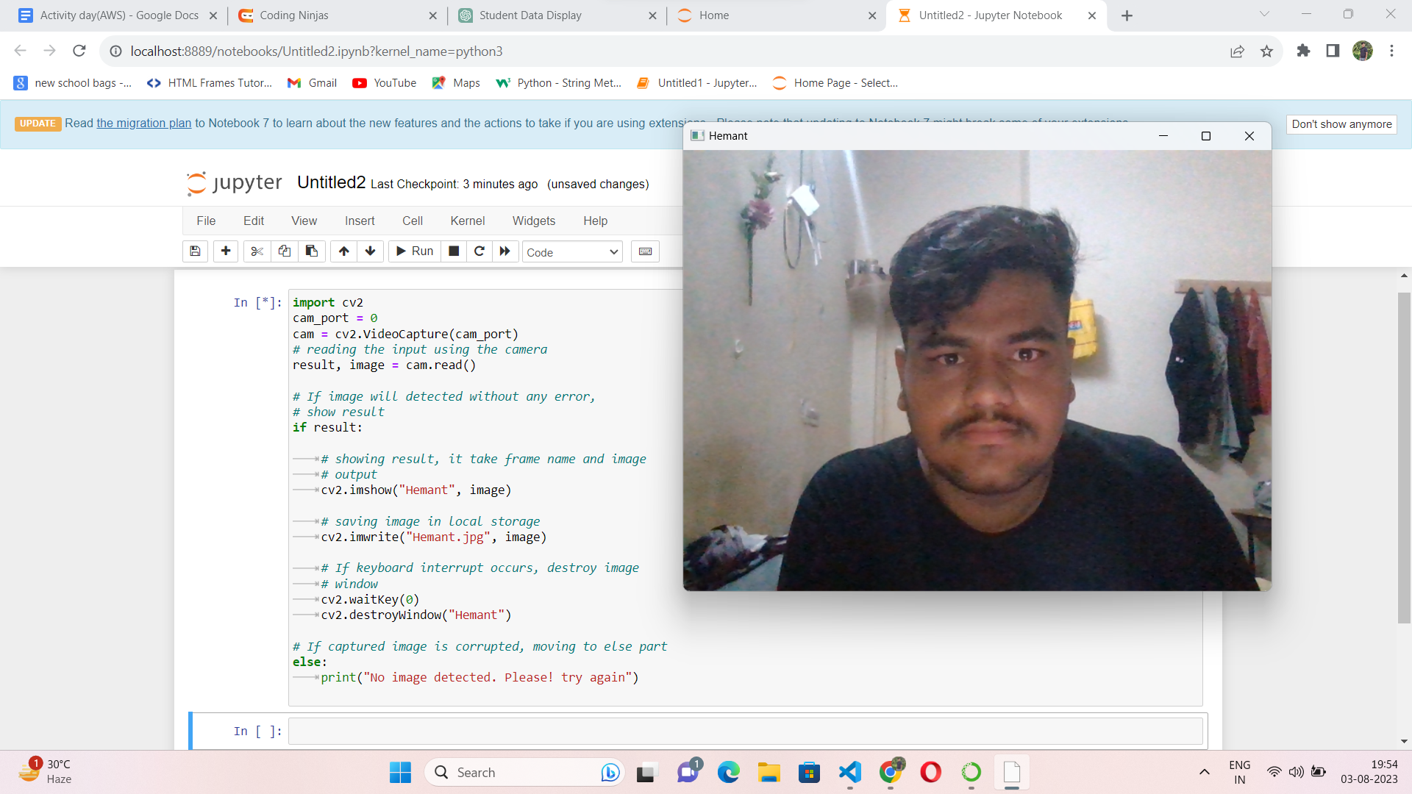

**Task 7:-**

* S3 bucket created and when file is uploaded it trigger a lambda function

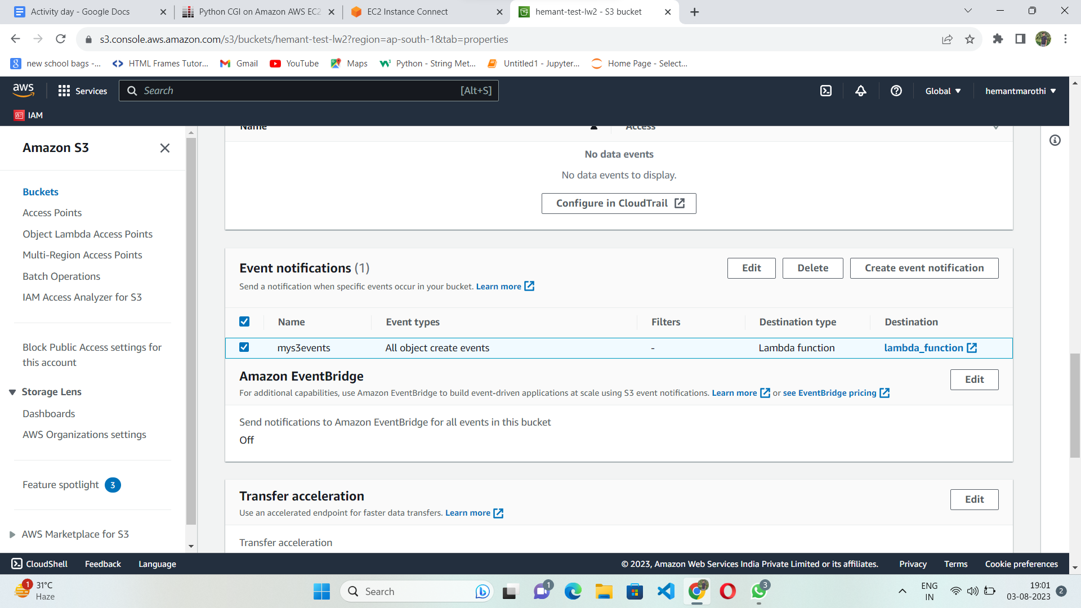

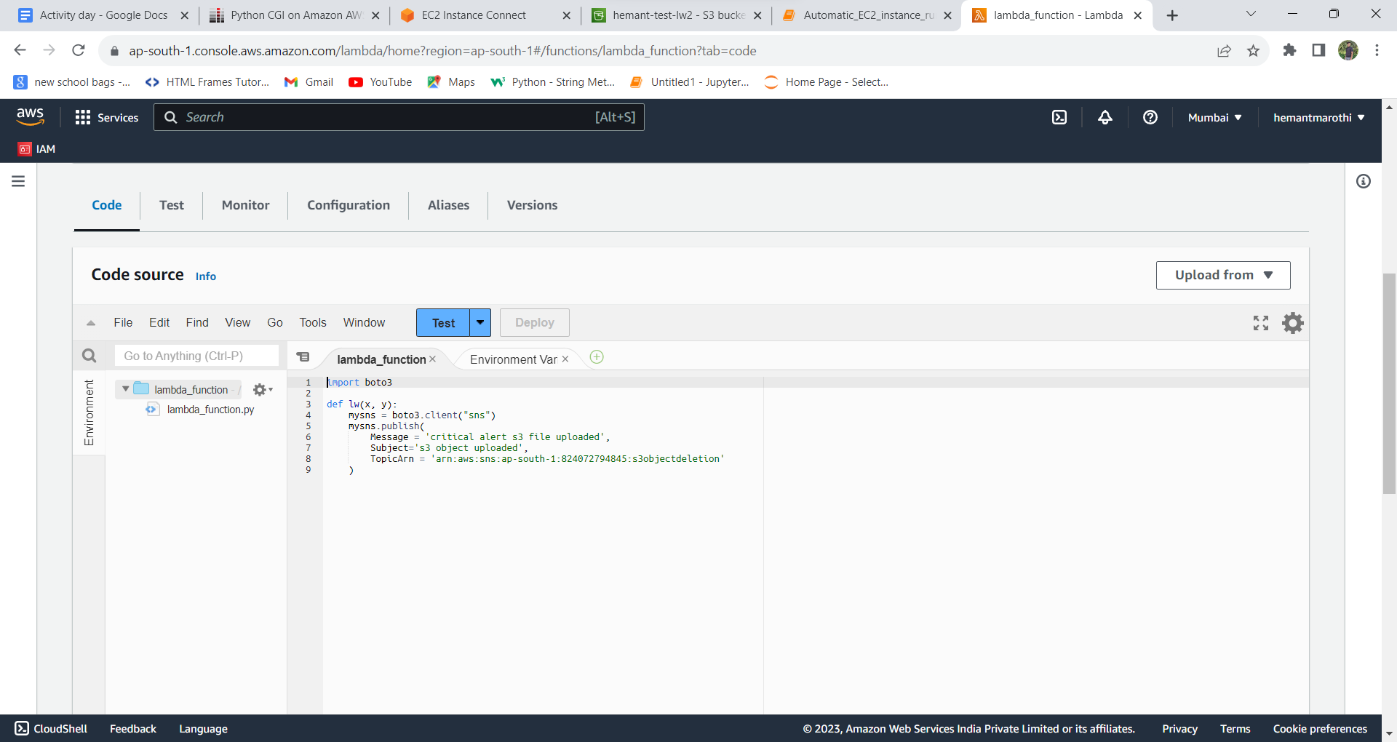

**Task 9:-**

* Launched EC2 instance successfully using boto3 library in python.

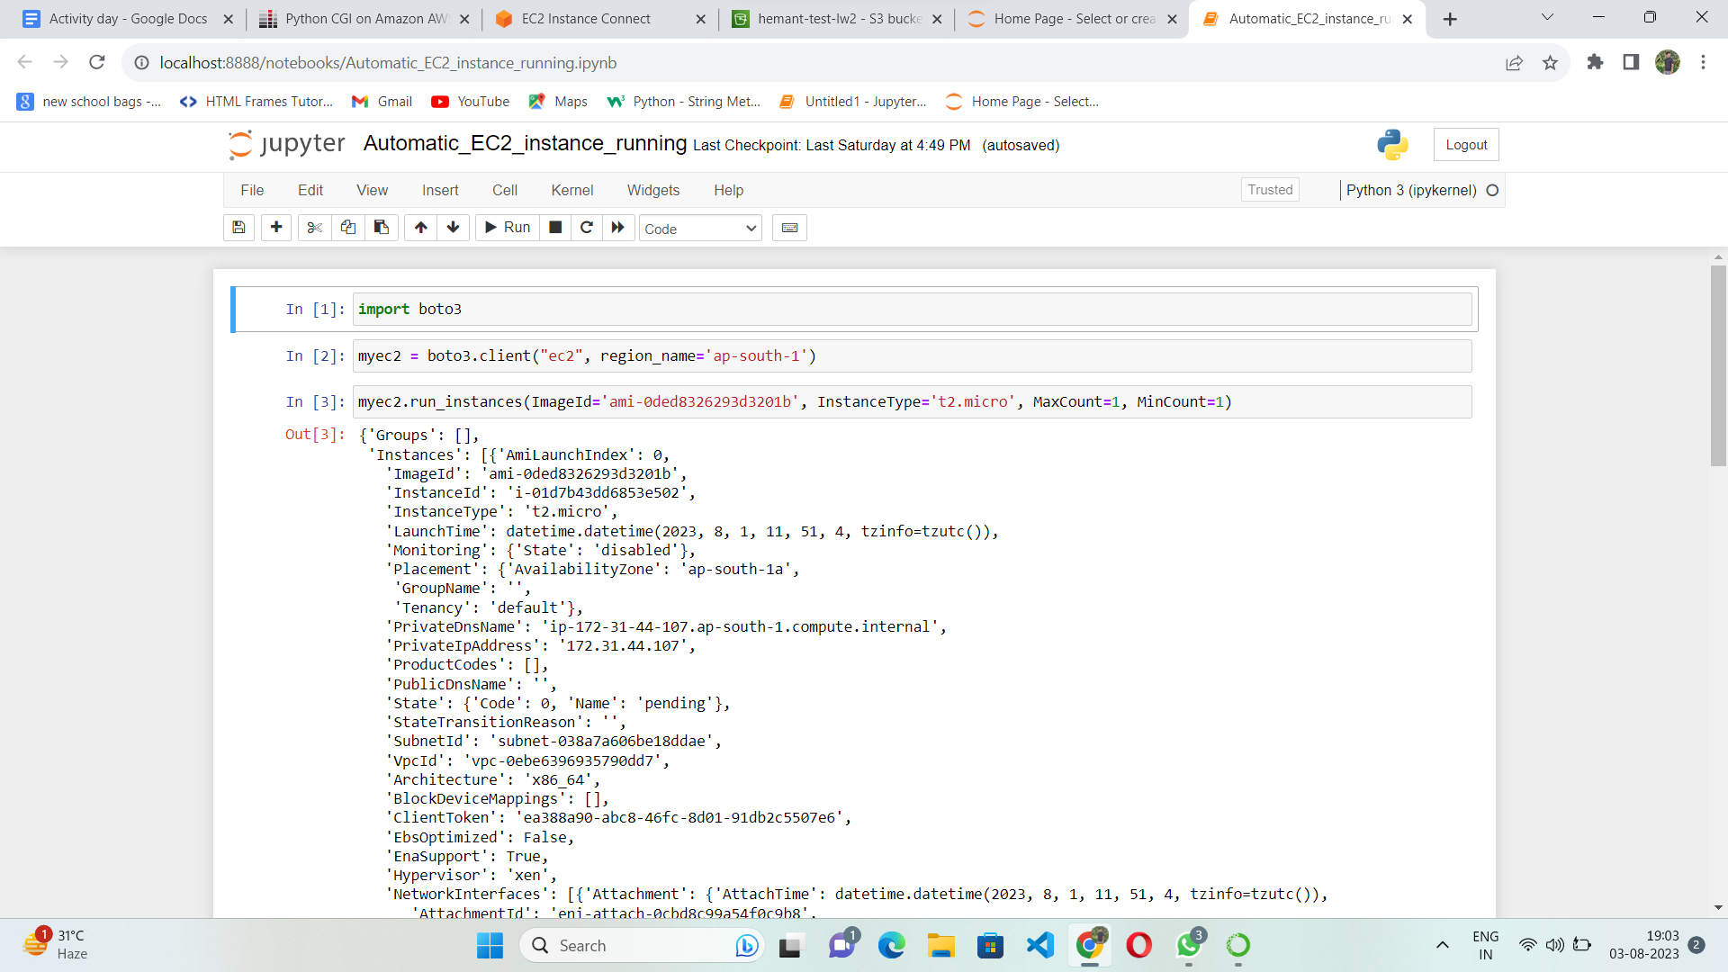

**Task 15( Booster task ):-**

AWS Lambda Image Resizer:

* Create an AWS Lambda function using Python to automatically resize images uploaded to an S3 bucket.
* Configure an S3 bucket event to trigger the Lambda function when new images are uploaded.
* Use Python libraries like Pillow to resize the images.
* Store the resized images back into another S3 bucket.